Story Outline

- Setting (Give a description of where and when this story is set)
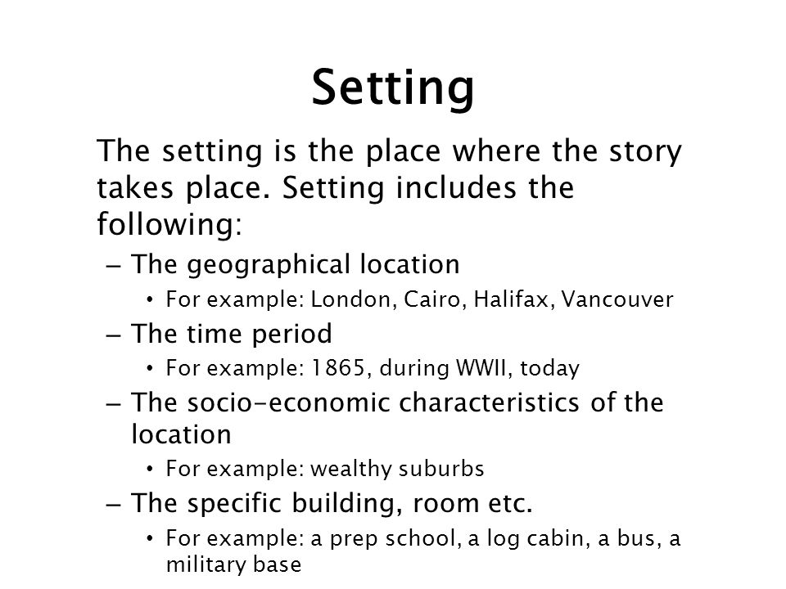

- Character Profile (Organise the basics for each character)
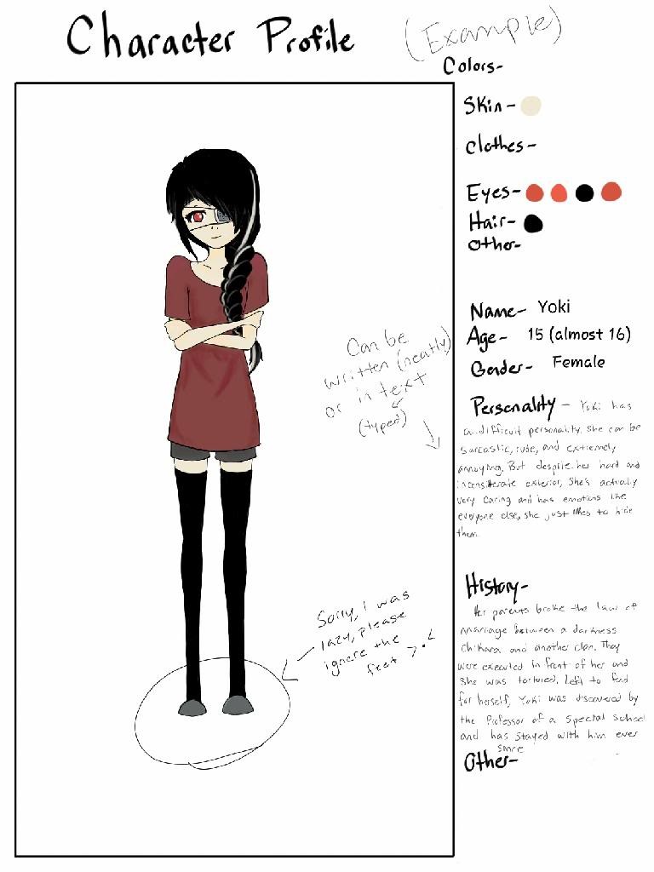

- Character Web (Show the relationships between the characters)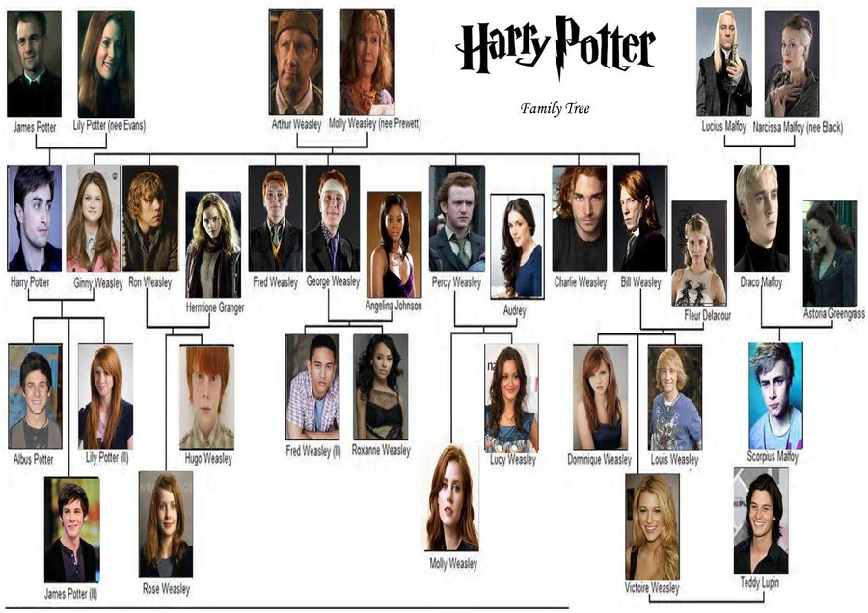

- Plot Timeline/Synopsis (Briefly tell the audience about the story)
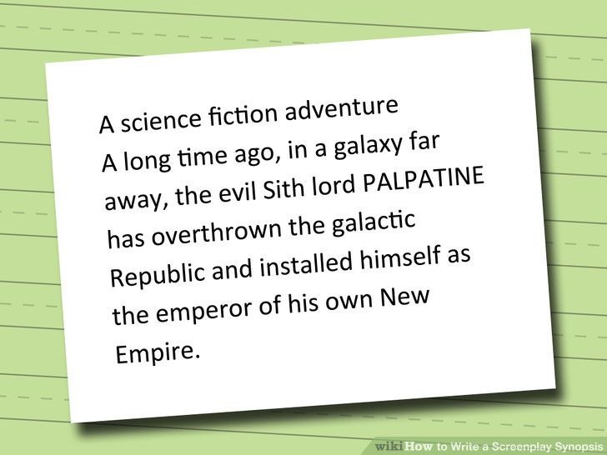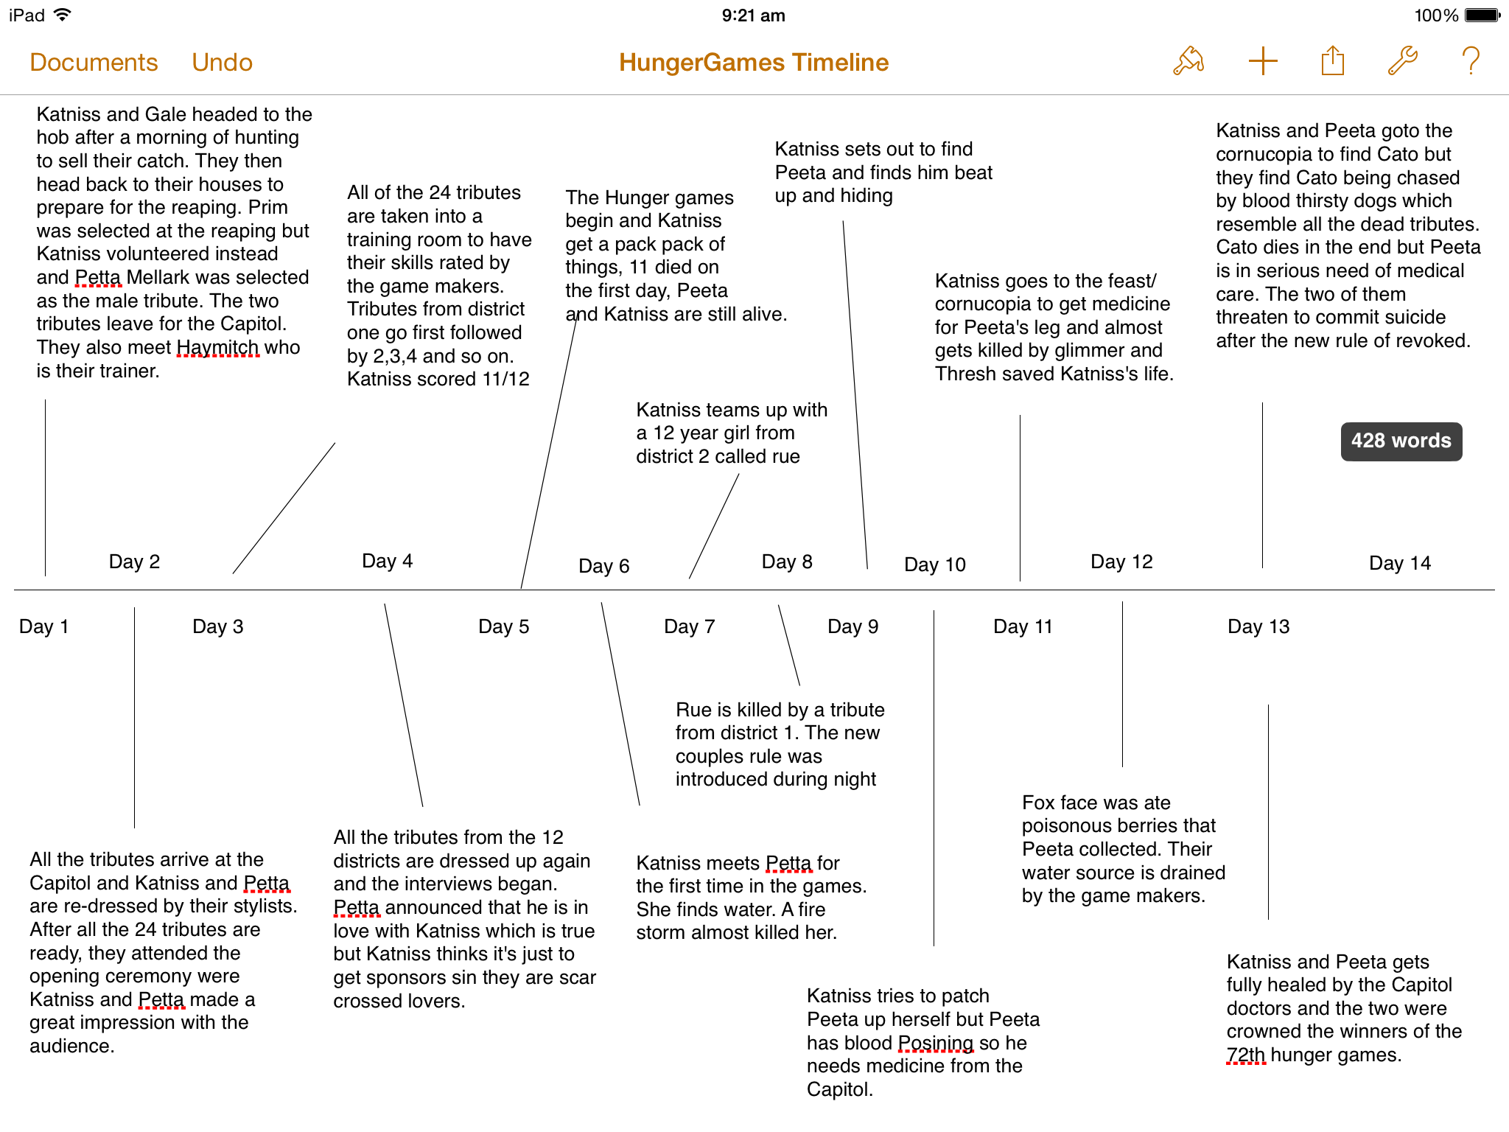

- Possible Beginnings/Introductions

- Possible Endings

